**Table of Contents**

Prerequisites 2

Steps to create S3 bucket 2

Steps to create IAM role 6

Steps to install SSM:  7

Steps to create documents in SSM 8

Steps to trigger PowerShell script 10

To select instance manually: 11

To select instance using tags: 11

To select the instance using resource group: 12

**Trigger PS script using SSM Agent**

Prerequisites**:**

* AWS system manager must be installed (SSM Agent) and in running state.
* AWS identity and access management role must be attached.
* Must have connectivity with System manager endpoints using SSM agent.
* User must have setupfile.ps1

Architecture

## AWS SSM Architecture (1)

## Steps to create S3 bucket

1. Go to AWS console and search S3

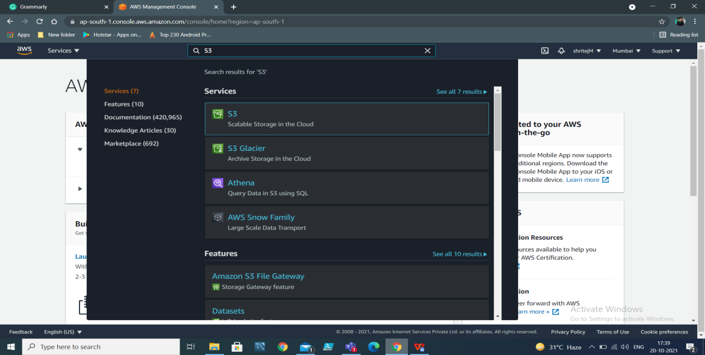

1. Then click on ‘create bucket’

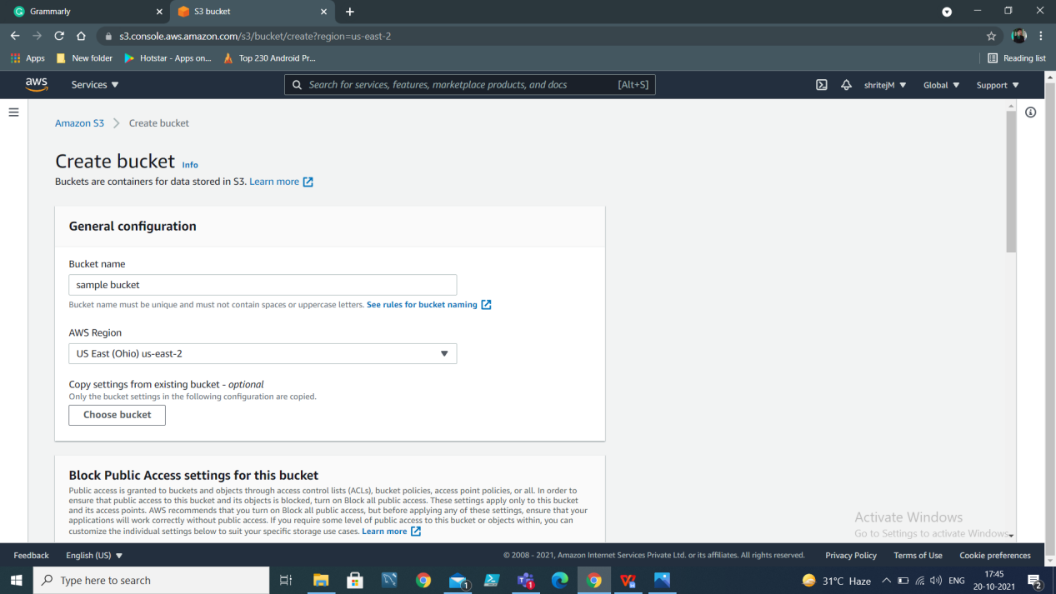

1. Give bucket name and select region US East (Ohio) us-east-2, then click on create button

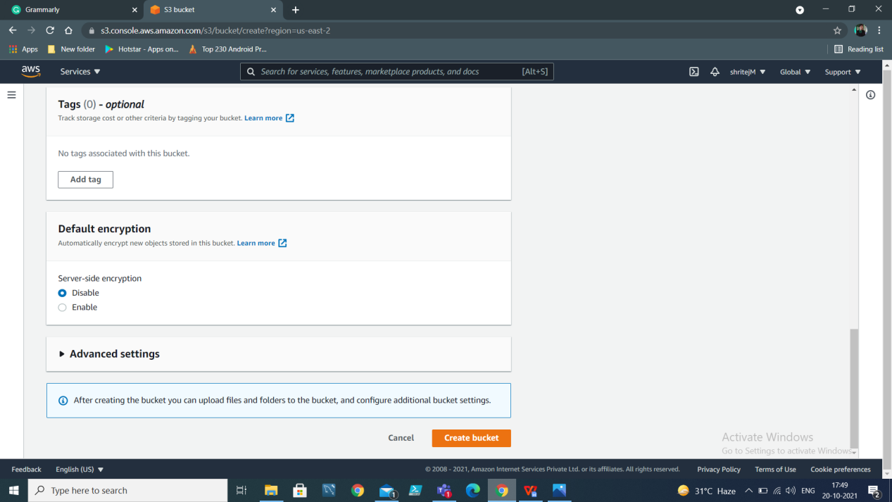

1. You will see bucket in S3

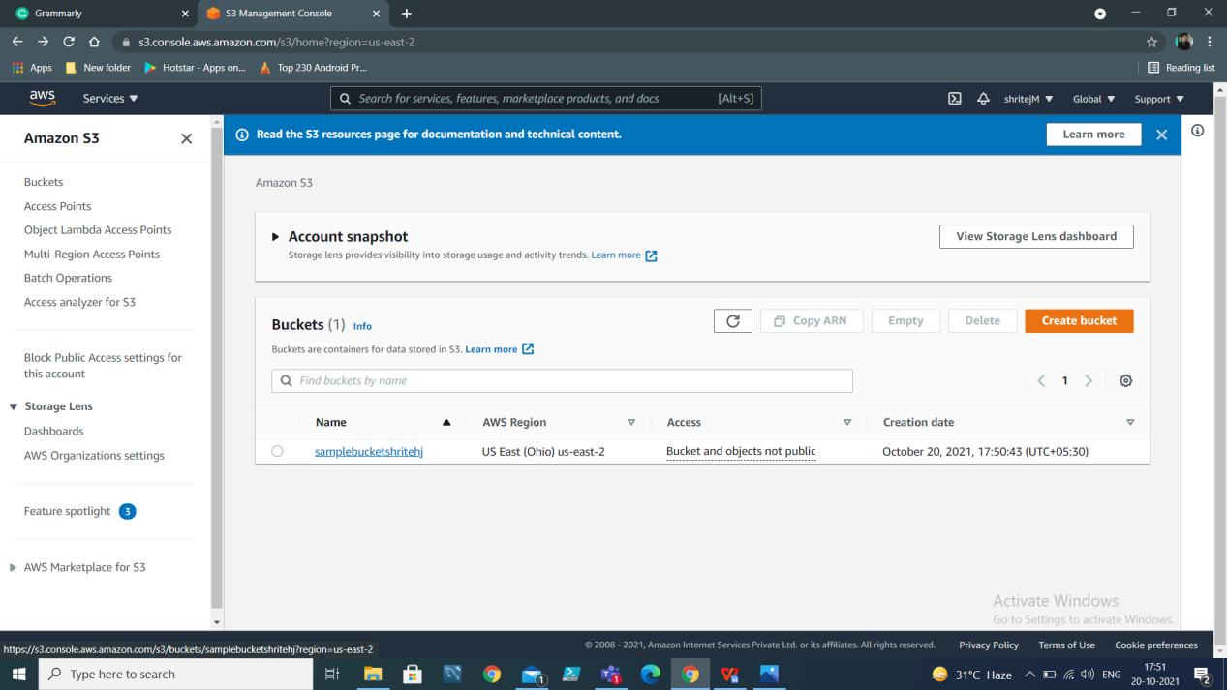

1. Click on create bucket to upload document

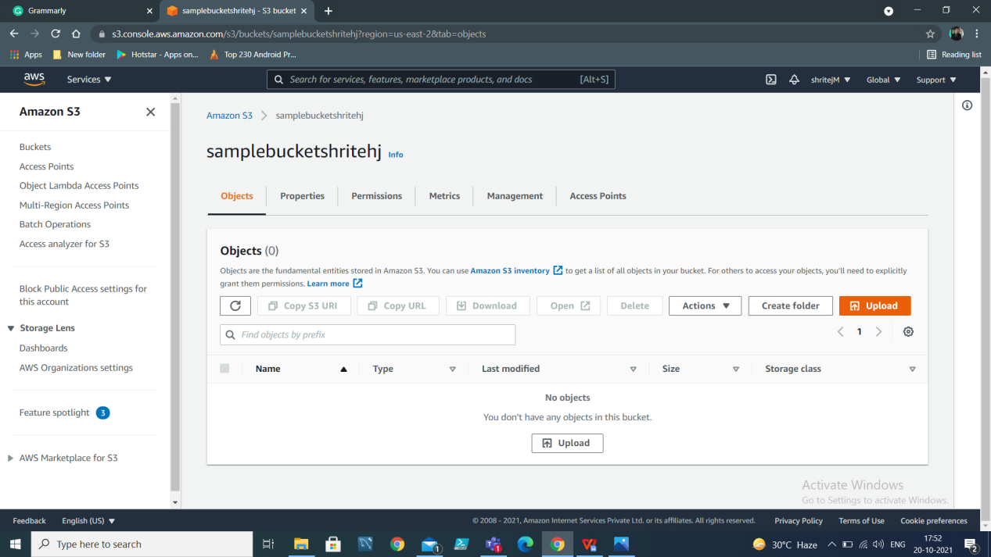

1. Click on upload button

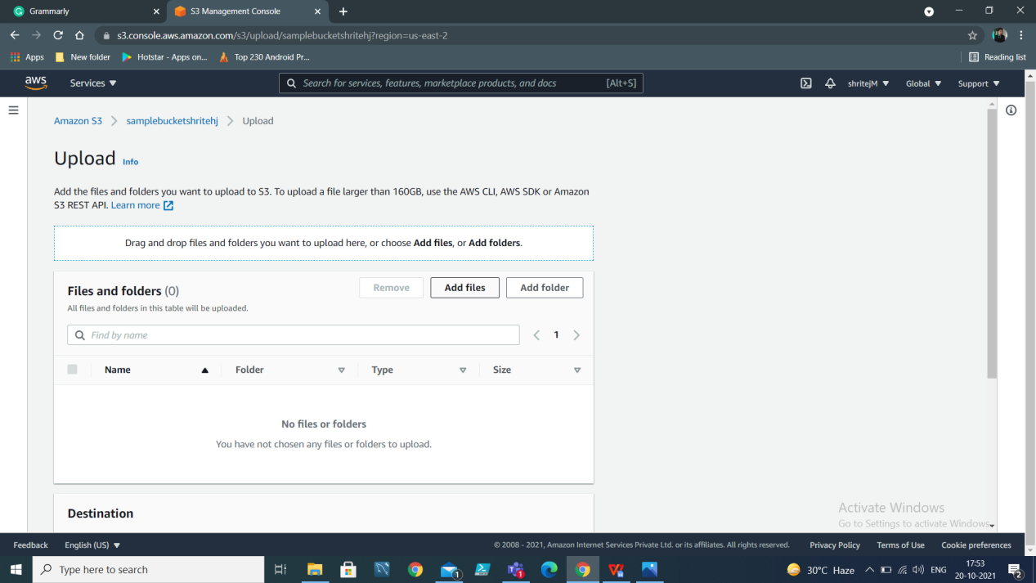

1. Click on Add files to upload your scripts

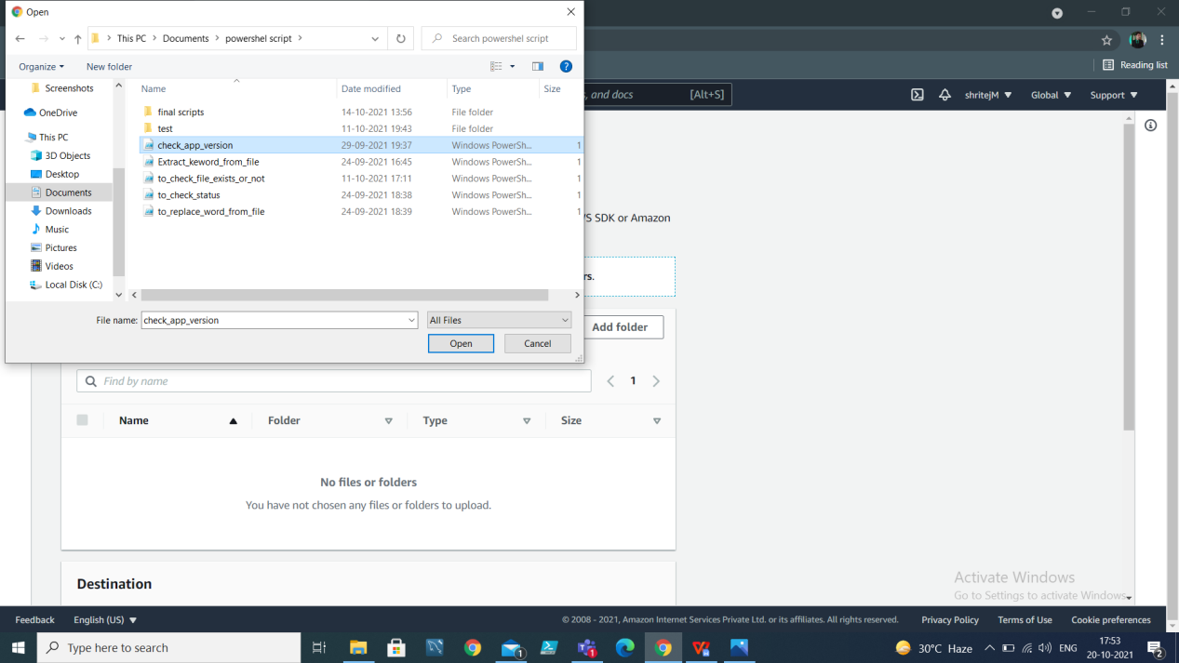

1. Click on upload button

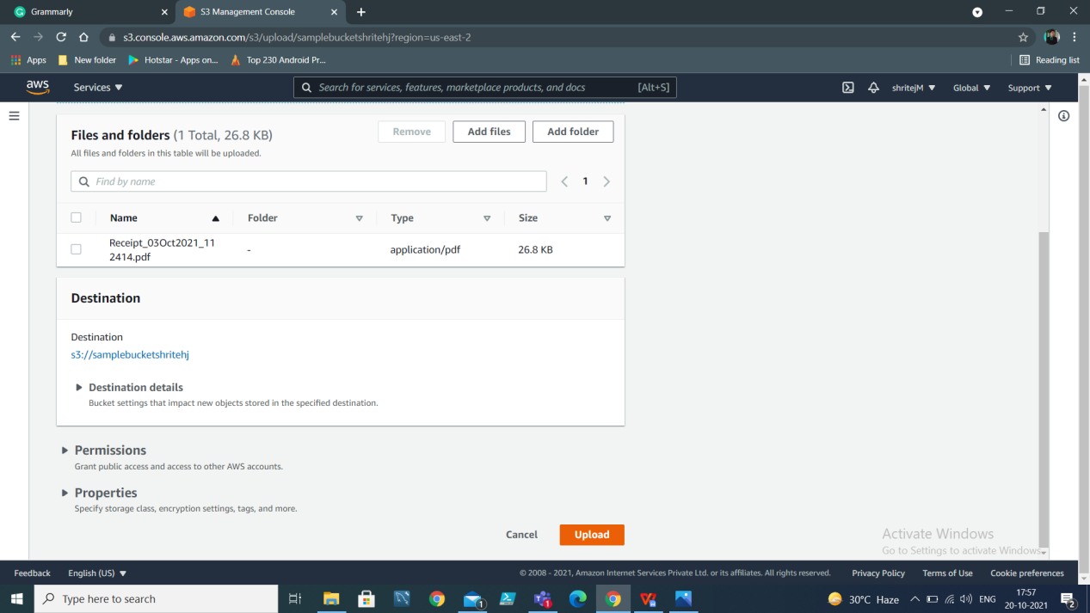

1. It will take time to upload file depending on the size of file

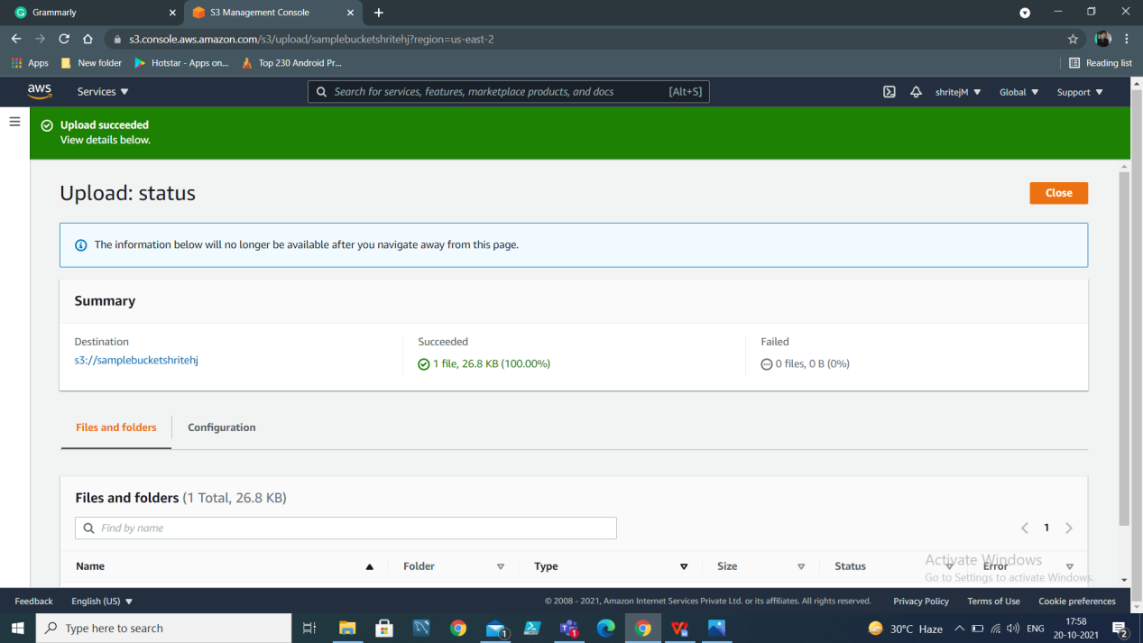

1. You will see file in your bucket

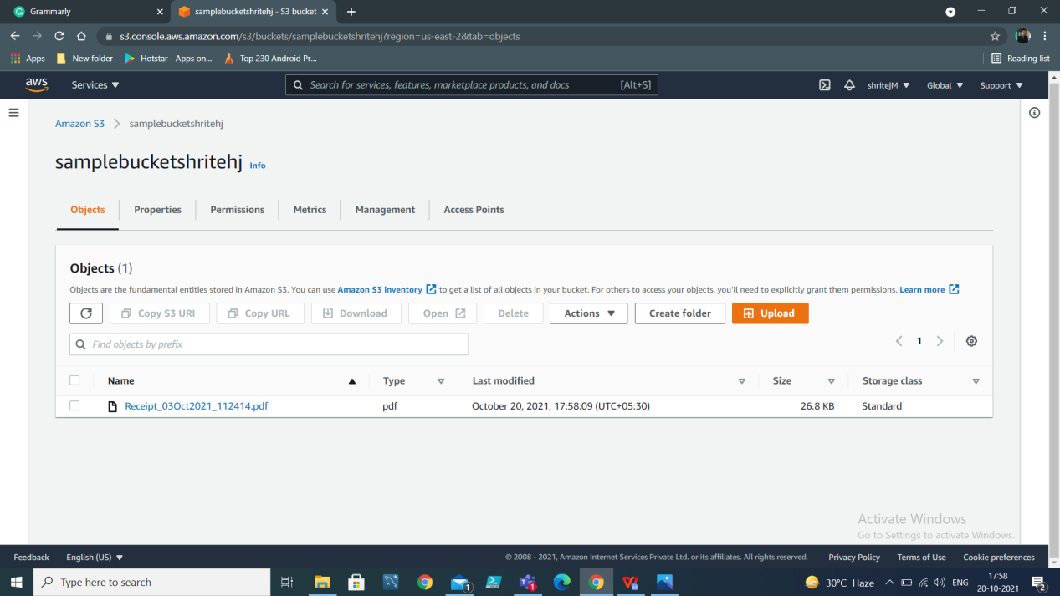

## Steps to create IAM role

1. Go to AWS console and search IAM

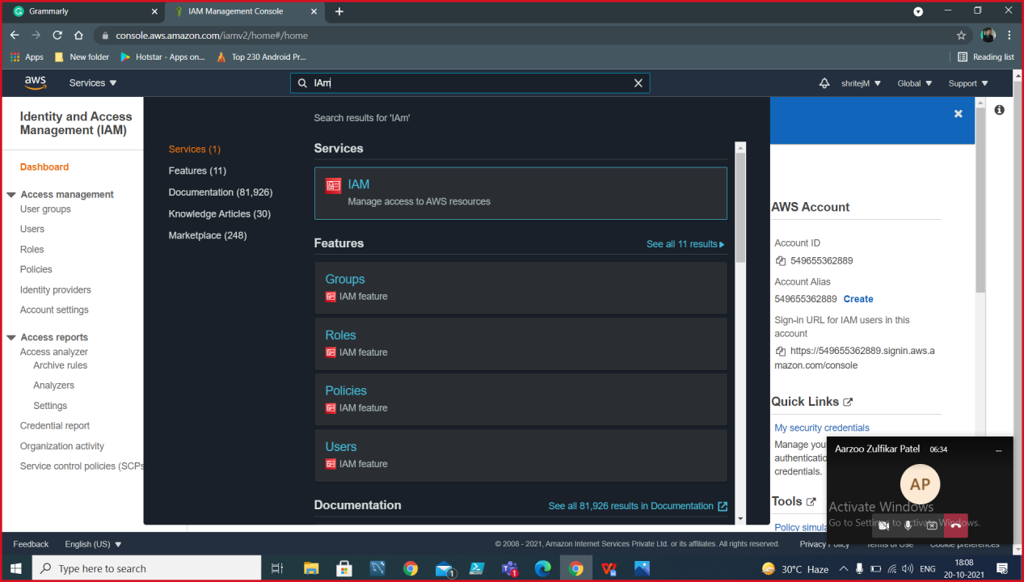

1. Click on ‘Create Role’

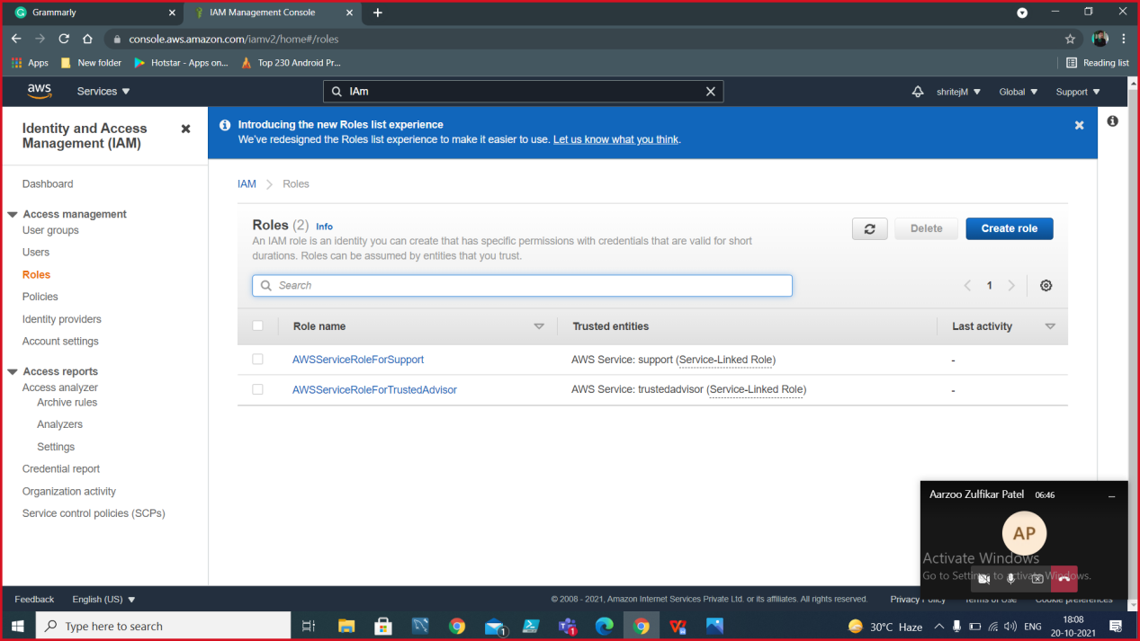

1. Select EC2 as the Use case and click on Next: Permissions

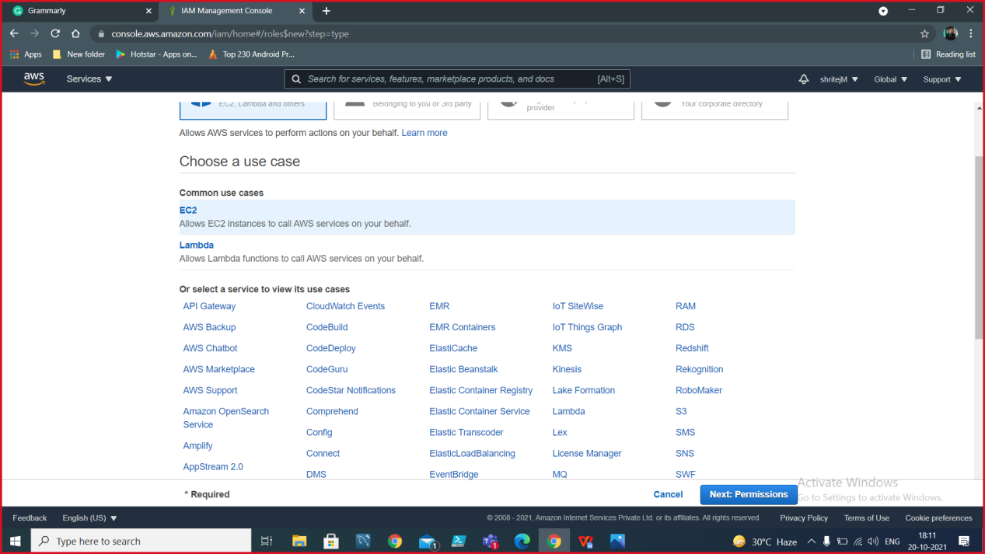

1. Select the below policies and then click on Next:

* AmazonEC2RoleforSSM
* CloudWatchAgentServerPolicy

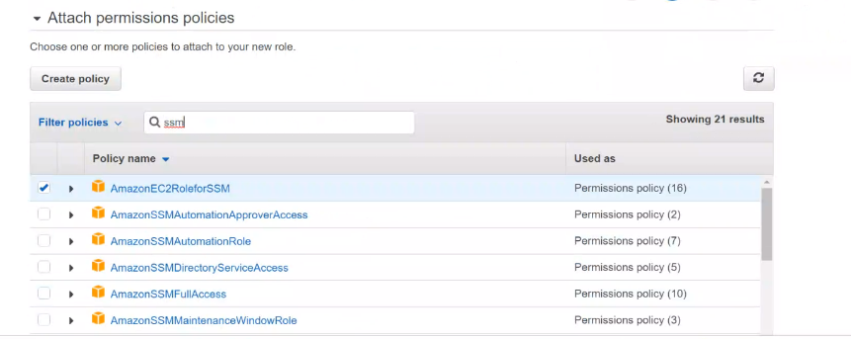

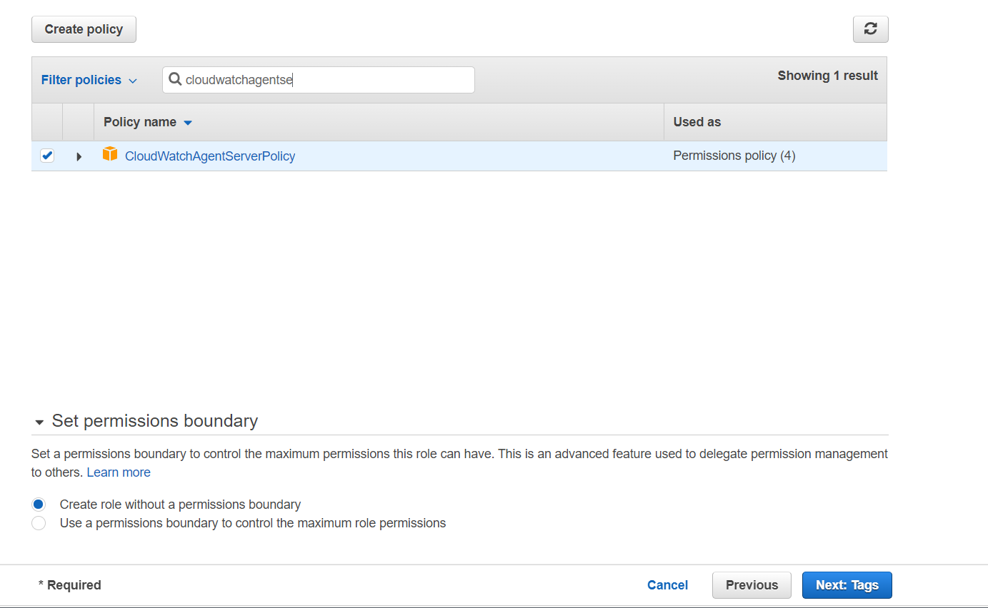

1. Then provide a tag

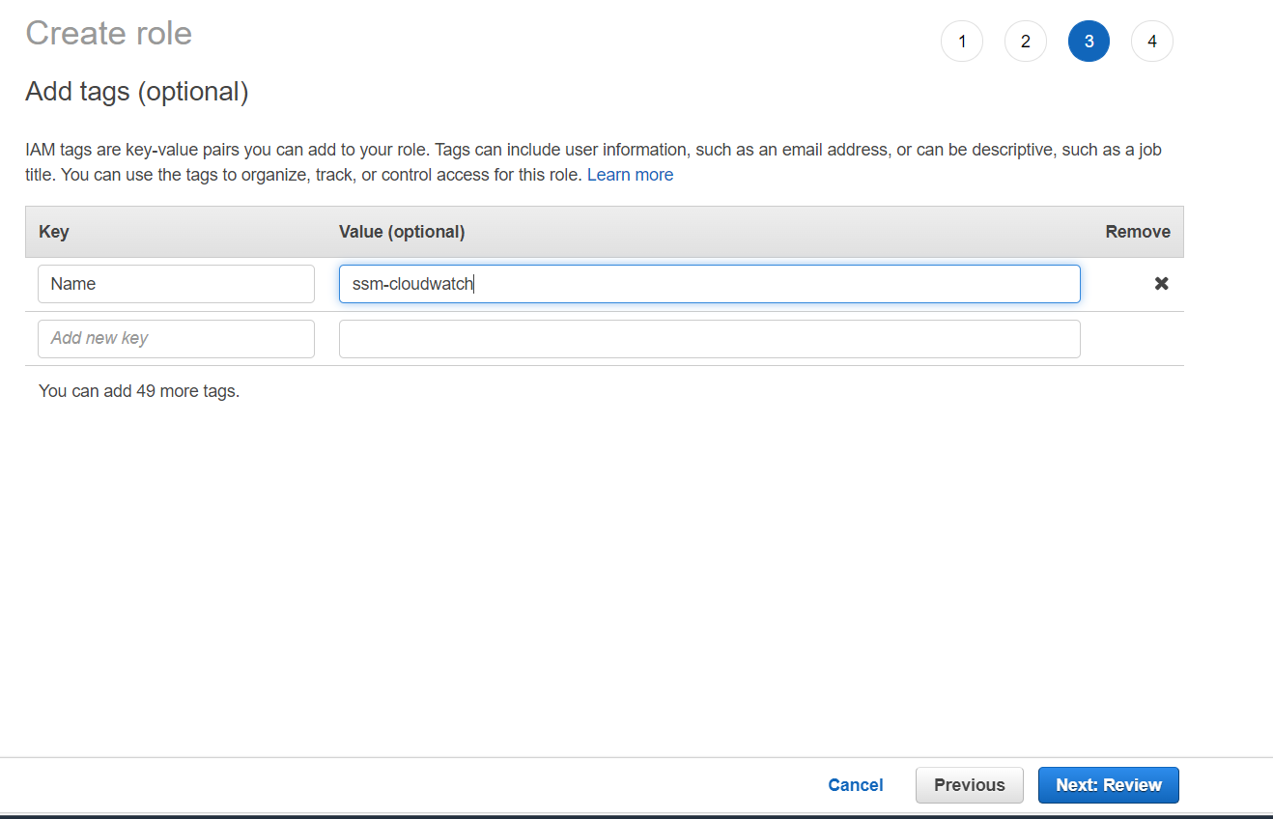

1. Provide other details: role name, role description and Create Role

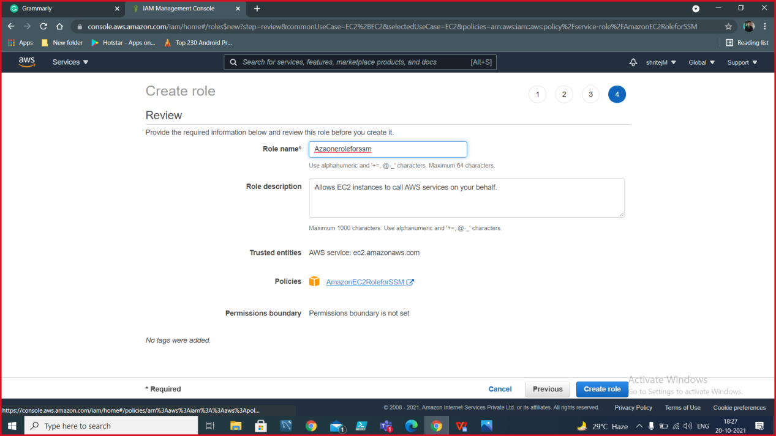

## Steps to install SSM:

1. Log in to the EC2 instance and type the following command in EC2 PowerShell.

|  |
| --- |
| *Invoke-WebRequest `*  *https://s3.amazonaws.com/ec2-downloads-windows/SSMAgent/latest/windows_amd64/AmazonSSMAgentSetup.exe*  *-OutFile $env:USERPROFILE\Desktop\SSMAgent_latest.exe* |

1. To start the process

|  |
| --- |
| *Start-Process ` -FilePath $env:USERPROFILE\Desktop\SSMAgent_latest.exe `*  *-ArgumentList "/S"*  *And*  *rm -Force $env:USERPROFILE\Desktop\SSMAgent_latest.exe* |

1. To restart SSM agent

|  |
| --- |
| *Restart-Service AmazonSSMAgent* |

**Steps to assign IAM role to instance**

1. Go to instances and select your EC2 instance.
2. Go to action>>security>>modify IAM role.

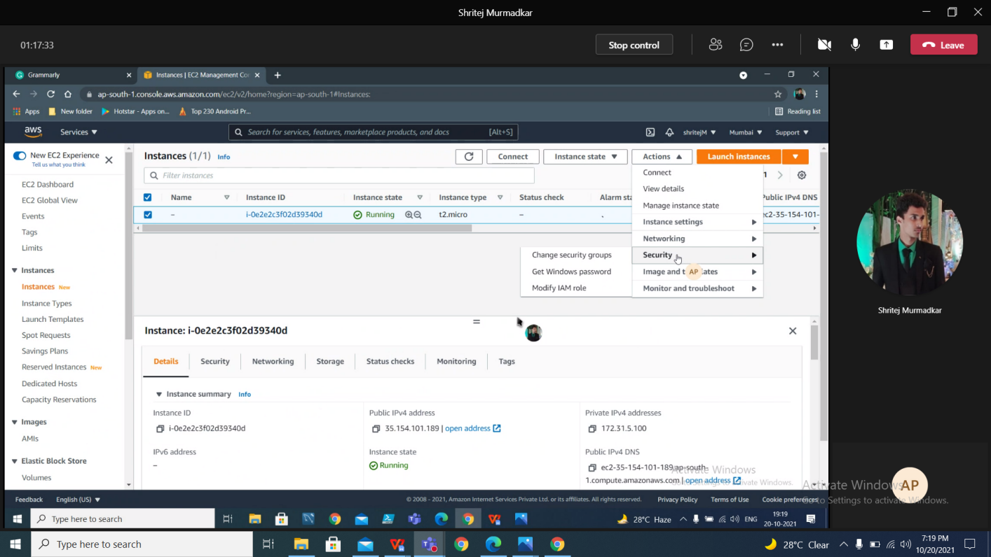

1. Select the role that you have created and click on save.

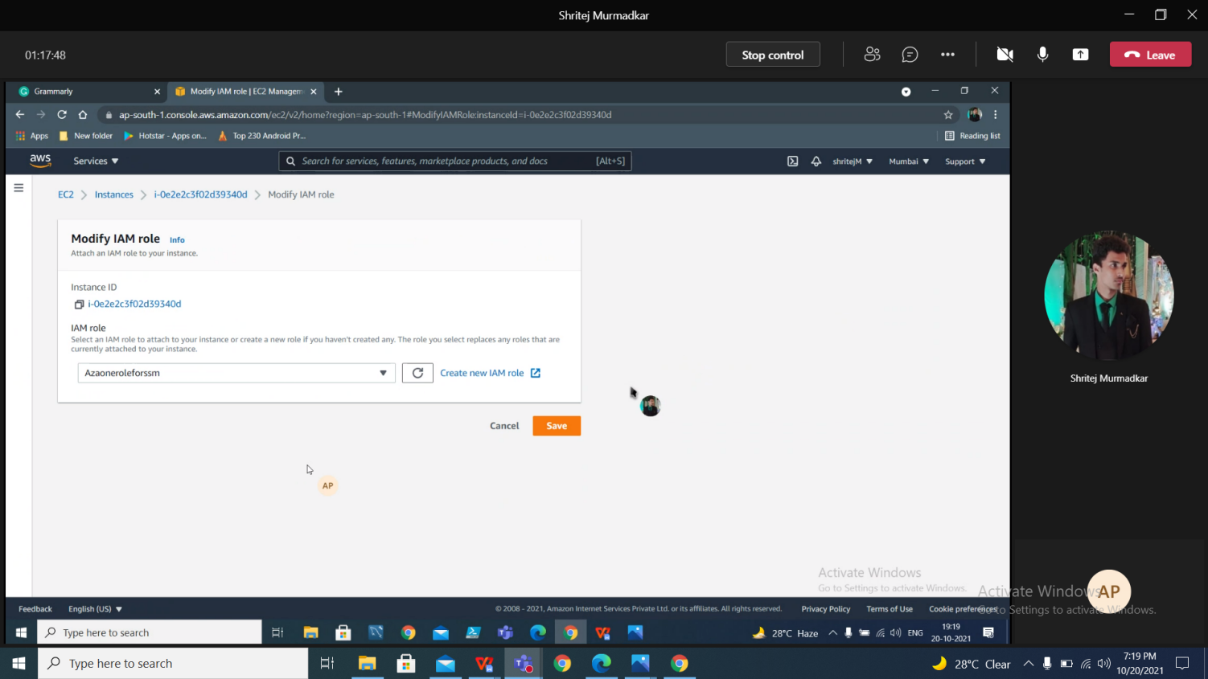

## Steps to create documents in SSM

1. Go to SSM>>Documents, then click on Create Documents and select Command or session.

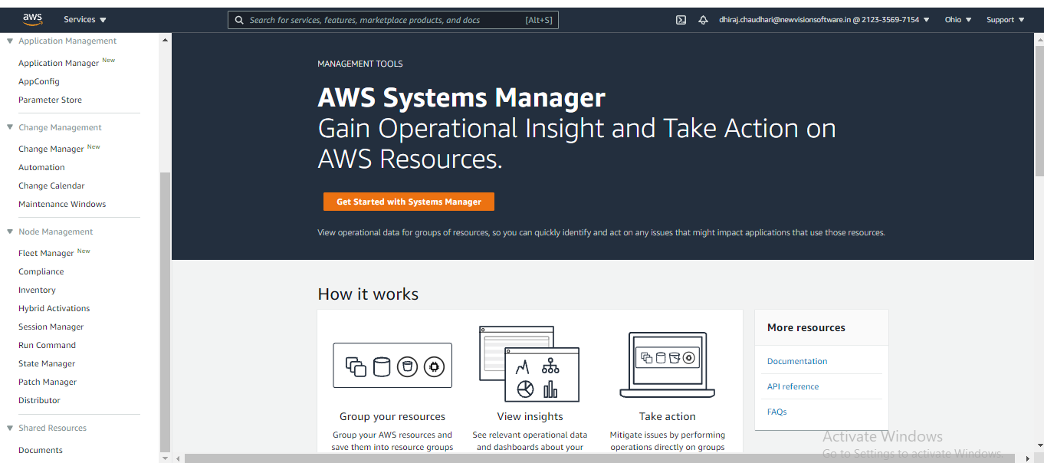

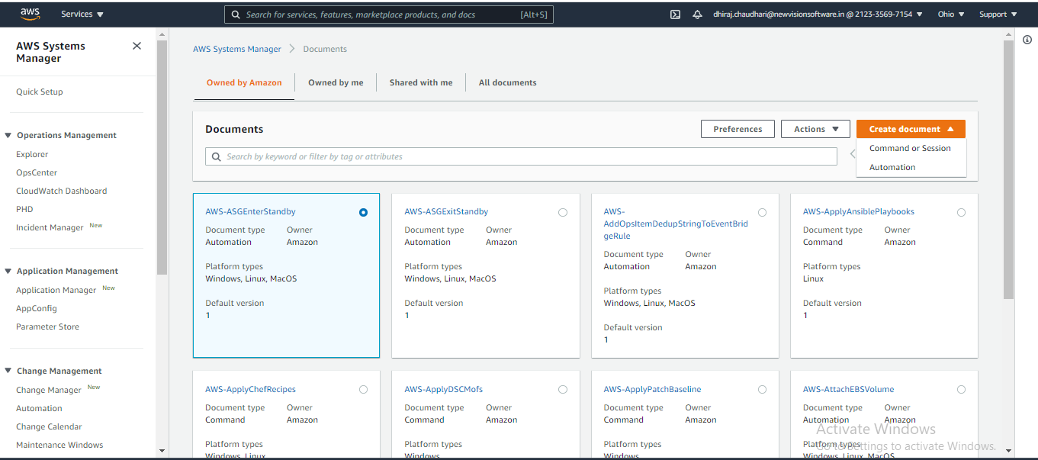

1. Enter the name of your document.

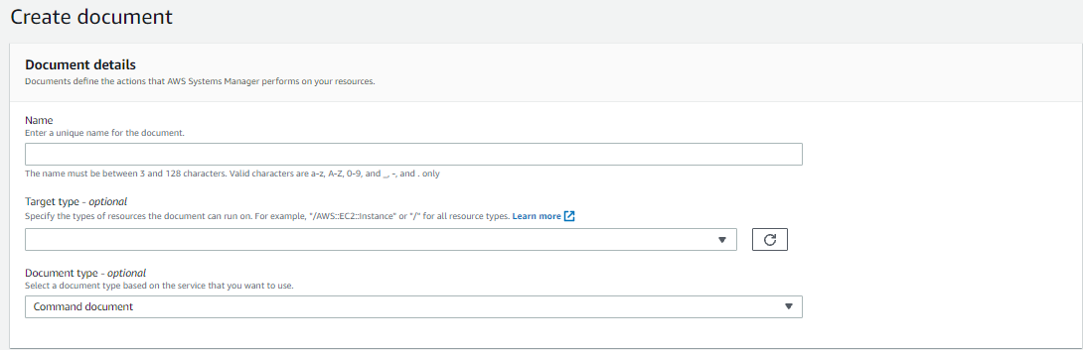

1. Select target type as /AWS::EC2::Instance.



1. Select content as YAML, you will see the YAML code.

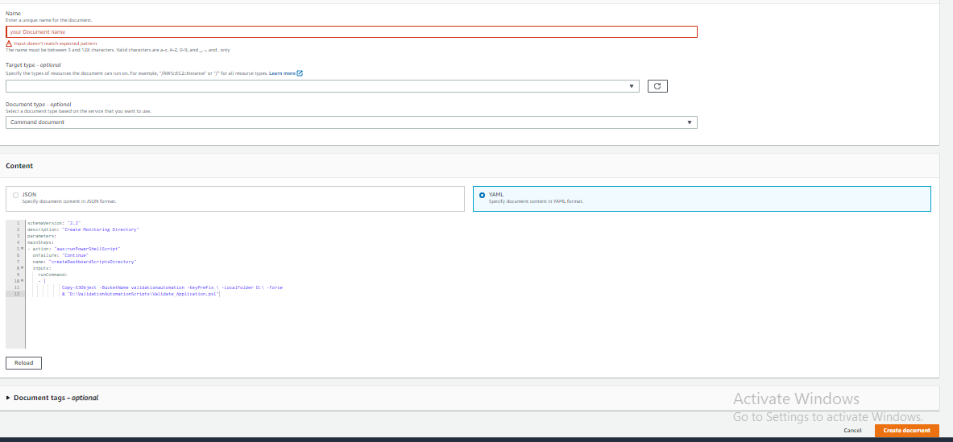

1. In the YAML code, Enter the PowerShell script inside runCommand {}
2. Then click on create document.
3. You will see the created document in SSM>>Documents>>Owned by me.

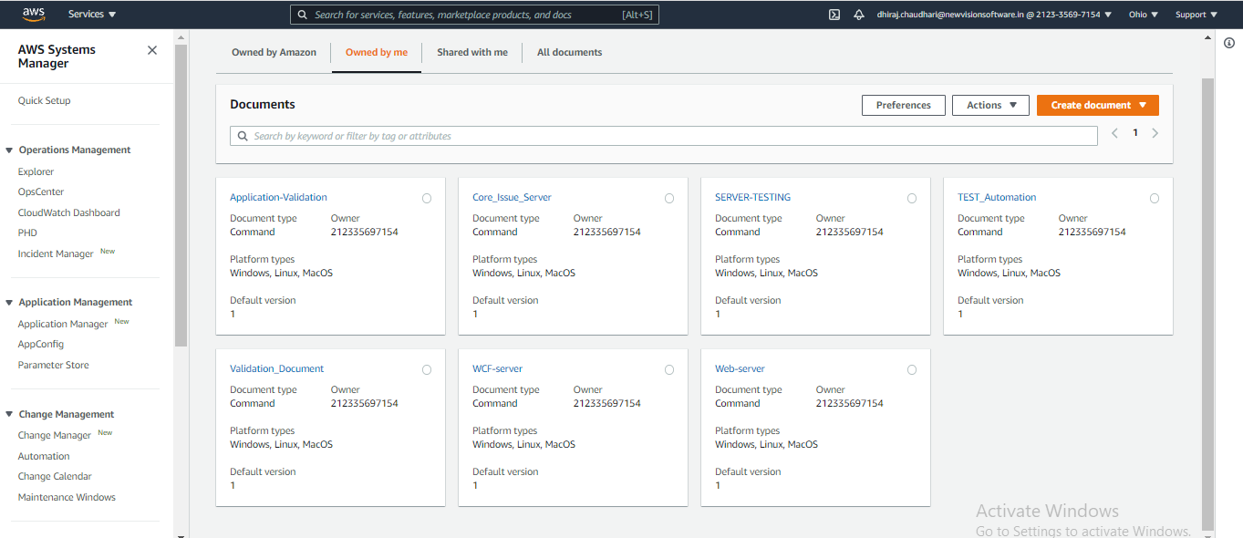

## Steps to trigger PowerShell script

1. Click on the created document and in content to see if the code is correct or not.

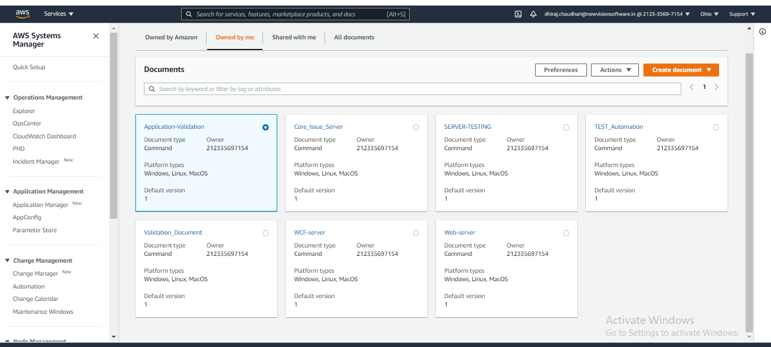

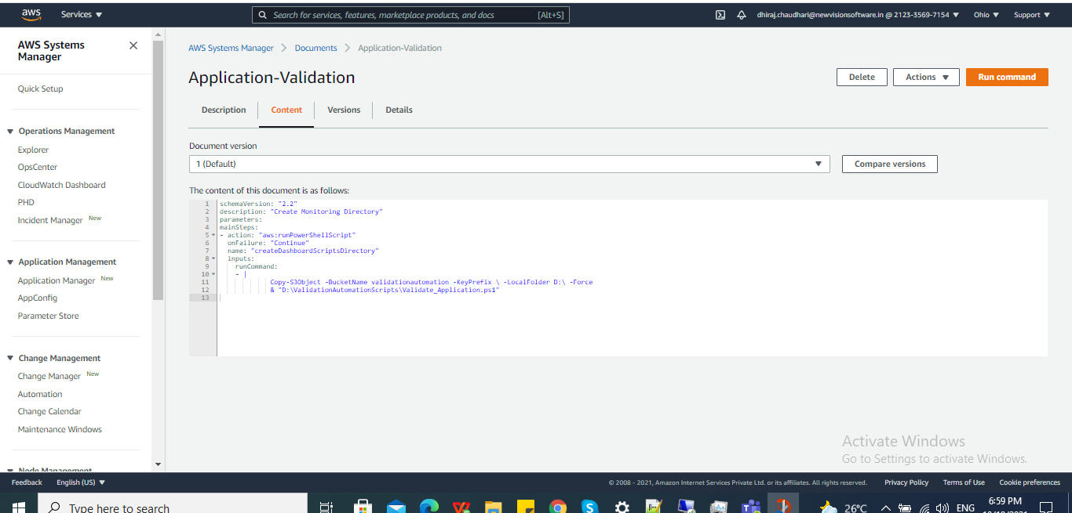

1. Then click on the **run** command and select instance.



1. You can select the instance manually or by using either tags or resource group.

To select instance manually:

1. Click on choose instances manually, you can select multiple instances.

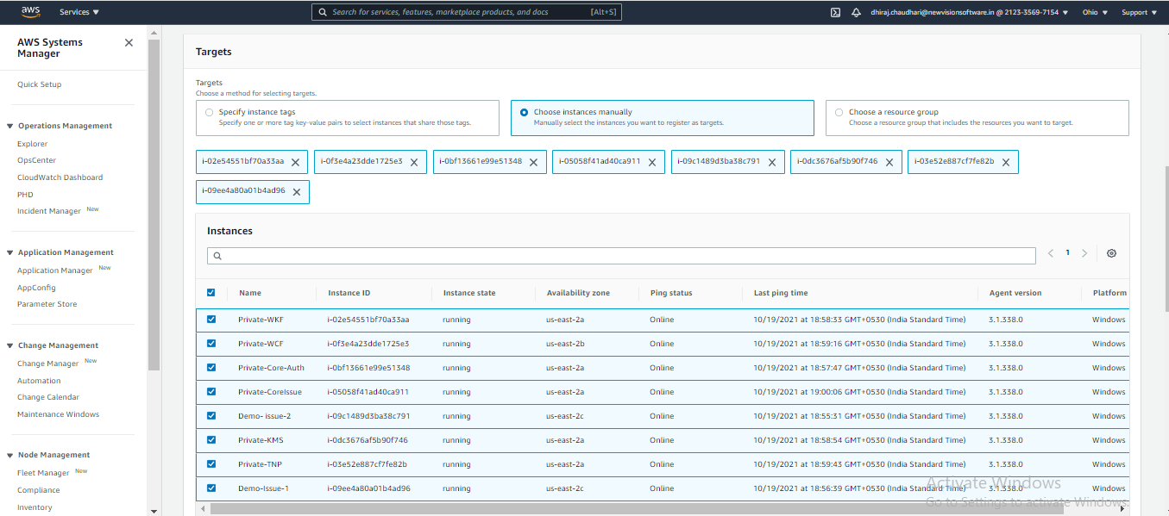

#### To select instance using tags:

1. Select specify instance tag.
2. Specify the instance tag key-value pair of the instance which you want to select.

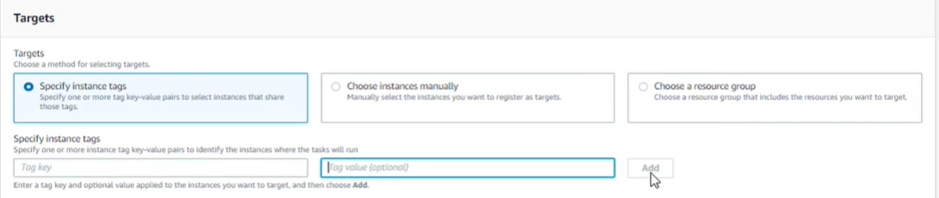

#### To select the instance using resource group:

1. Select choose a resource group.
2. Specify the name of resource group which you want to choose as a target.

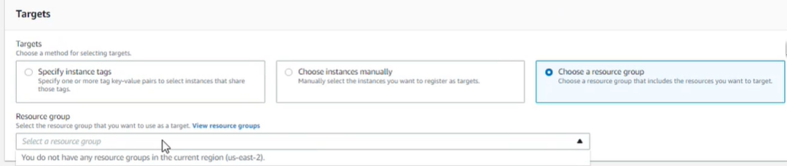



1. Click on Run.
2. After clicking on run you will get command ID, here you can see the status of the command.

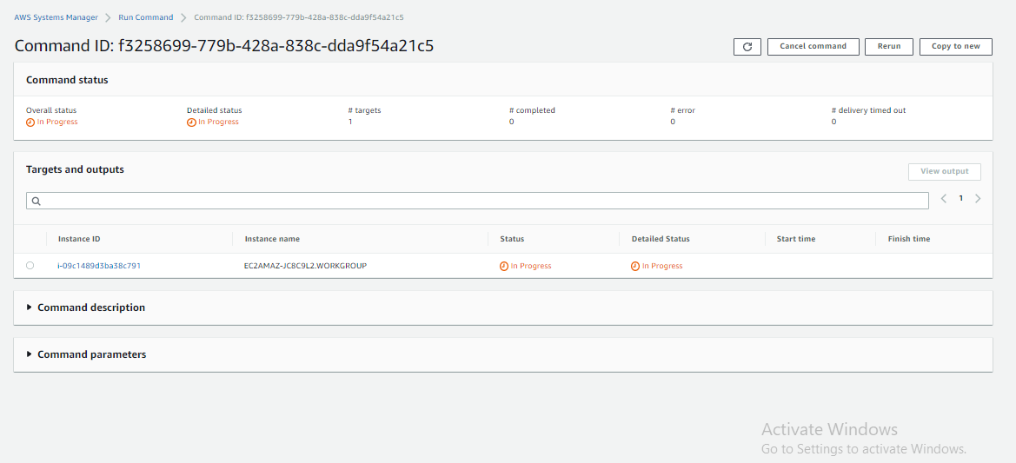

1. It will take time to reflect output.

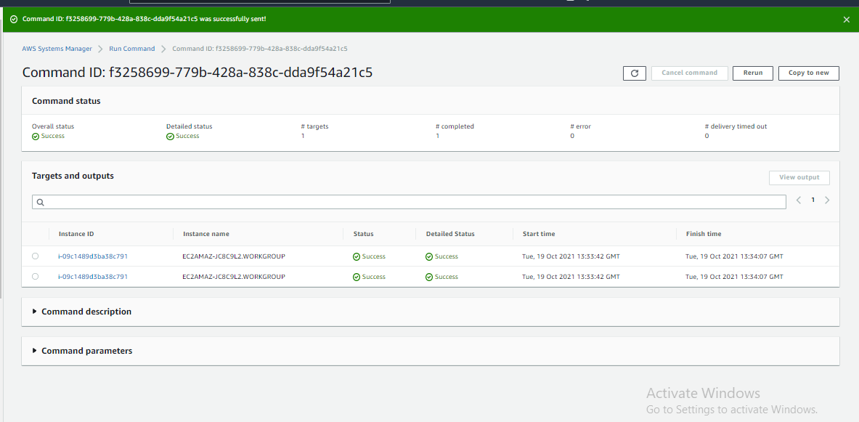

1. In targets and output you will see instance id.



1. Click on instance id, after clicking on instance id you will see the output and error if any.

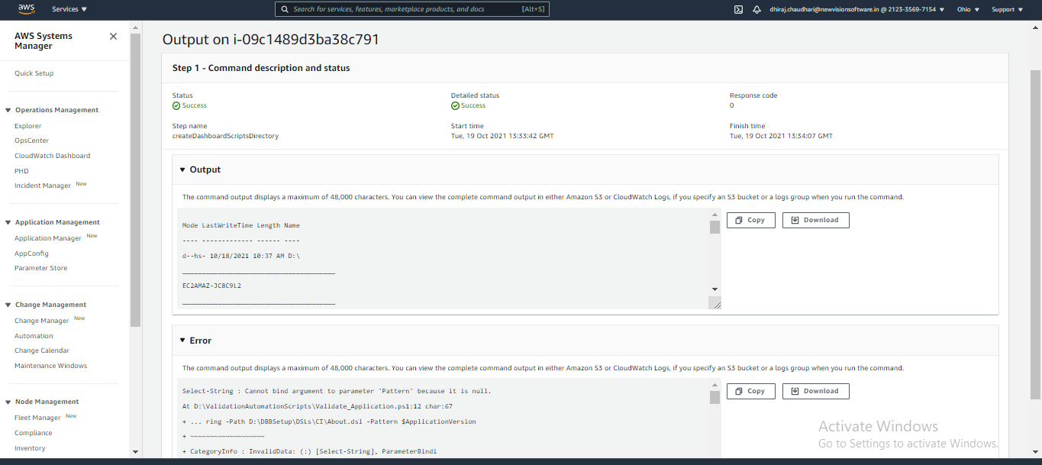

**Steps to trigger PowerShell script on server:**